Resources for Caregivers

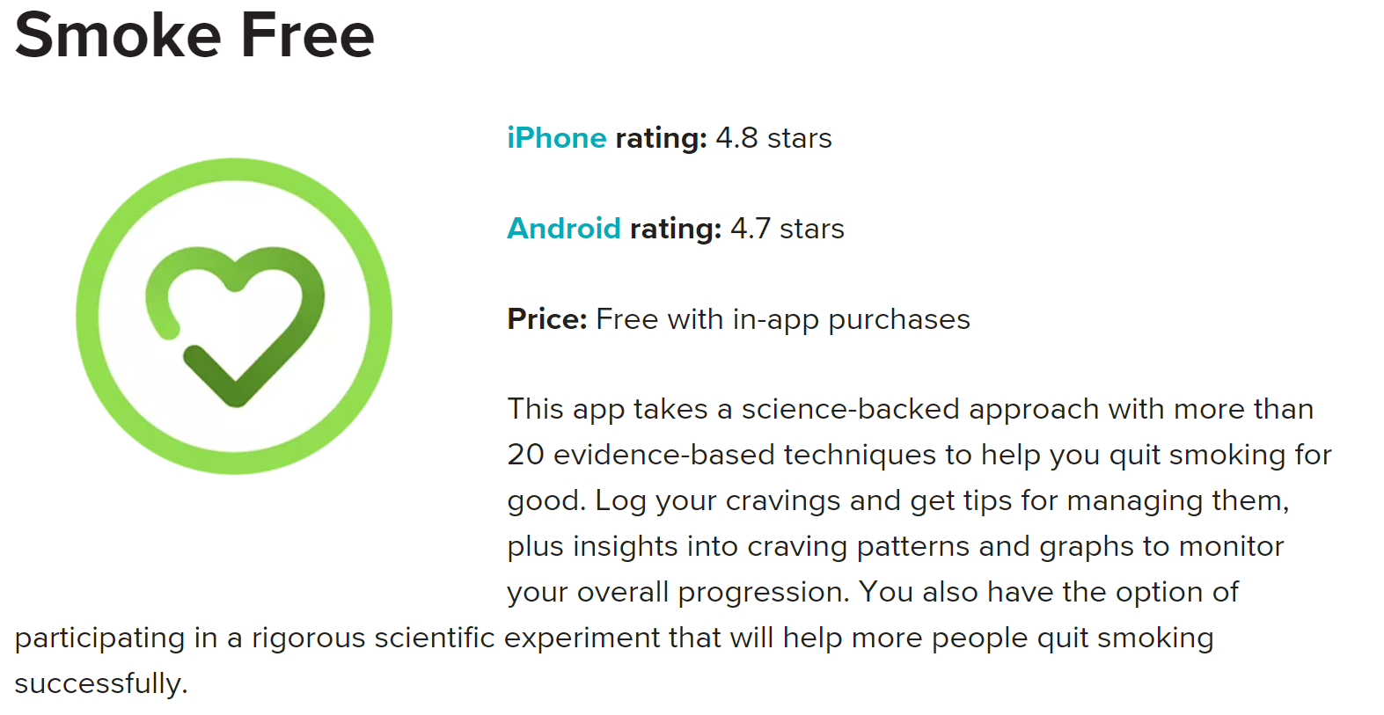
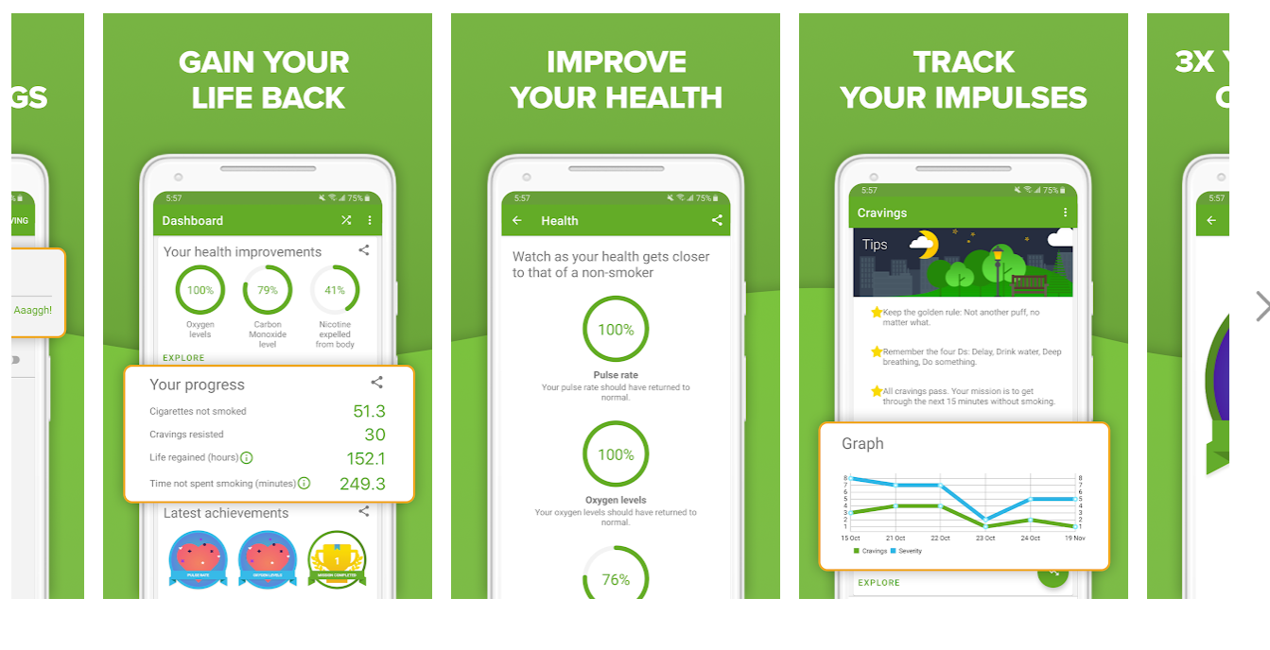
Quit smoking using the app that science built. Stop smoking with 30+ proven techniques designed to help you. More than double your chances of quitting and let your next cigarette be your last. Smoke Free helps you conquer tobacco cravings for good.
Smoke Free can help any cigarette smoker stop smoking for good. Whether you have attempted to quit cigarettes before or are trying to stop for the first time, are quitting by yourself or are part of a quitting group, Smoke Free’s scientifically tested and proven techniques work. Don’t let your cravings take over. Use Smoke Free to help you succeed.
Quitting is hard and we make it easier to stop smoking by using several quit smoking features including:
• Quit smoking tracker - See how many cigarettes you have not smoked
• Challenge tracker - Complete Missions and earn Badges for your progress
• Smoking log - Track and log successful days you’ve been smoke free
• Share your successes with your friends
• Record your cravings in a diary
• And more!
Smoke Free helps you make better choices by showing you the benefits of quitting cigarettes.
Health matters, and Smoke Free knows it. We have several features to measure your health as you move along your quitting journey. Watch your health improve with every cigarette you don’t smoke. Better, healthy habits are created when you log and monitor your health improvement daily.
Smoke Free’s health features include:
• Health improvement charts that measure your progress
• Health diary and craving log to monitor and control healthy habits
• Health tracker to see how your health is improving
Smoking cessation is our specialty. We understand what works when you want to stop smoking and conquer cravings. We have done extensive research and want to share our knowledge to help you.
Some helpful information for your quitting process:
• Nicotine replacement therapy helps people stop smoking, but needs to be directed
• Smoking cessation social programs are a helpful support.
• The Quit Now Golden Rule: make your mantra ‘not one more puff’.
• Remember that this is your quit and we help you find what works for you.
Quitting smoking is a Smoke Free community effort. Your quitting wins can help other smokers quit. The more Smoke Free understands about our users, the bigger effect we have on their success.

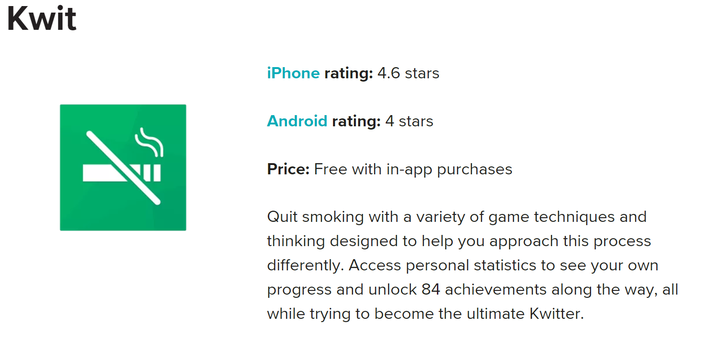

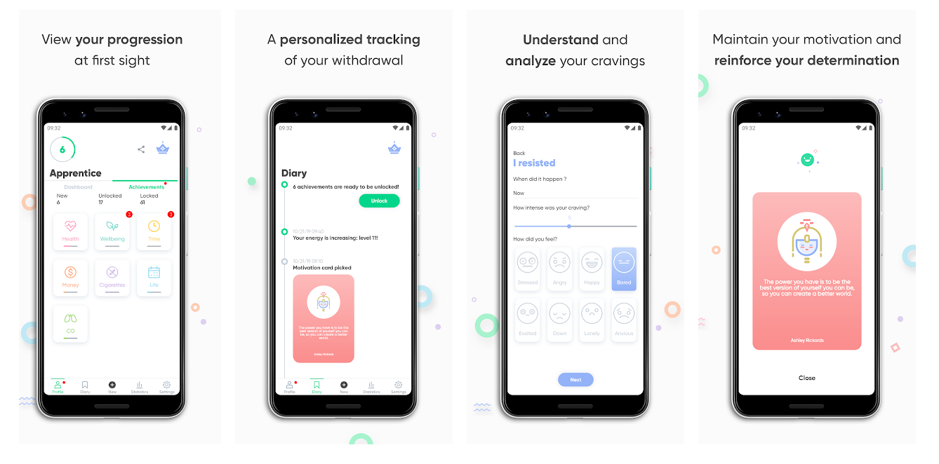
I have not been able to personally check this one out.
Use Kwit – Quit smoking for good – Smoking cessation to quit smoking for good, get tips to avoid cravings and reach the highest achievements. Make use of one of the most efficient and innovative stop smoking apps free for your mobile device. See why games, achievements and social media can be one of the best way to quit smoking!
🚭QUIT SMOKING WITH GAME TECNIQUE & MECHANICS
This health app for your android can help you quit smoking for good using various game techniques, mechanics and thinking to encourage you to stop smoking. You will be able to access many statistics with information about how much time passed since you smoked your last cigarette, how money you saved and how many cigarettes you haven’t smoked. All these statistics you can monitor in live with this quit smoking app.
✨ ACHIEVEMENTS & MOTIVATIONAL CARDS
With this smoking app for your android you can get many achievements depending on the time that passed since you quit smoking. About 84 achievements you can unlock to see all the benefits of stopping smoking. Try to become the ultimate Kwitter with getting high rankings! With this smoking cessation, you are able to shake your phone and get a motivational card. With more than 200 available cards on this quit smoking app you will get through the cravings easier.
💫 SHARE YOUR PROGRESS ON SOCIAL MEDIA
Unlock new achievements and get high rankings on this health app. Use Social media to share your achievements on this smoking app, help and motivate your friends to stop smoking.
🚭 KWIT FEATURES
✔️Quit smoking using various game techniques and mechanisms
✔️Unlock 84 achievements to see benefits of stopping smoking
✔️Get high rankings and become ultimate Kwitter
✔️Shake your phone and get more than 200 motivational cards
✔️Share progress on social media
✔️For phones and tablets
✔️Free for download
Quit smoking with this amazing app, get through your cravings and share achievements with friends.
See why we have been reviewed as one of the best way to quit smoking.
Download it now for FREE!
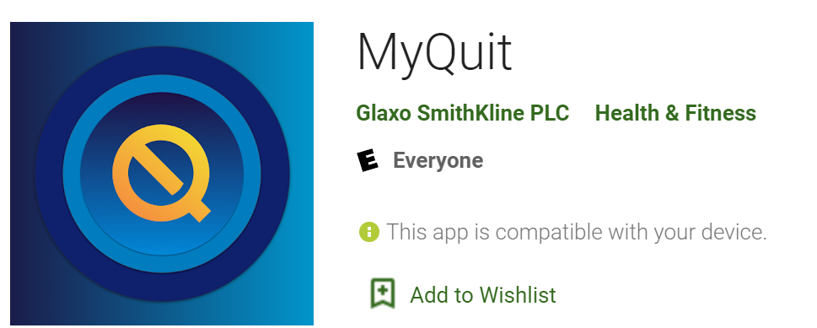

FEATURES
TRACK YOUR CRAVINGS
Recognize, manage and keep track of your personal smoking triggers through GPS mapping. You can even edit your previously logged cravings to pinpoint the times and places where the possibility of slip-ups are high.
SUPPORT, ADVICE AND TIPS FROM SUCCESSFUL QUITTERS
Hear from people who have quit smoking and are feeling great. It can really inspire you.
GET REWARDS AND SAVINGS
Receive rewards for your quit milestones with badges and savings on Nicorette® and NicoDerm® CQ® products.
FIND YOUR INSPIRATION
Customize the “What’s your why?” wallpaper to help you keep your determination strong.
SEE HOW MUCH YOUR QUIT IS SAVING YOU
Keep count of how much money you’re saving by quitting smoking on the “Money Saved” tracker.
CUSTOMIZE YOUR QUIT
Pick your quit date, select your nicotine replacement preference if you are using one, and get started. The MyQuit™ App will be there to help.
CELEBRATE EVERY CIGARETTE YOU DON’T SMOKE
The MyQuit™ App can help you keep track of every cigarette you avoid. Because each one is a little win.
GET THE RIGHT SUPPORT WHEN YOU NEED IT
Receive timely information to you help manage craving and stay motivated.
PERSONALIZE YOUR DASHBOARD
With a new refined dashboard layout you can tailor your profile to be your personal quit hub. You’ll be able to enter your info and navigate your quit milestones with an easy-to-use interface. You can even set up your dashboard according to the information that’s most important to your quit.
SOPHISTICATED DATA CHARTS
Easy to understand data charts allow you to see exactly what triggers your cigarette cravings and when and where they’re likely to strike so you can get ahead.
WILL HELP YOU TO LOG AND TRACK YOUR NRT IF YOU ARE USING ONE
If you use nicotine gum or lozenge, you can log and track when you use your nicotine replacement therapy so you can be sure you’re getting the most out of your product.
LOG SLIP-UPS
Quitting smoking is hard and slip-ups happen. It doesn’t mean you’ve failed. The MyQuit™ App lets you log slip-ups so can get a better understanding of when they’re likely to hit.
SEE YOUR PROGRESS
The new progress timeline allows you to easily follow your quit milestones to see how far you’ve come as you move through your quit.

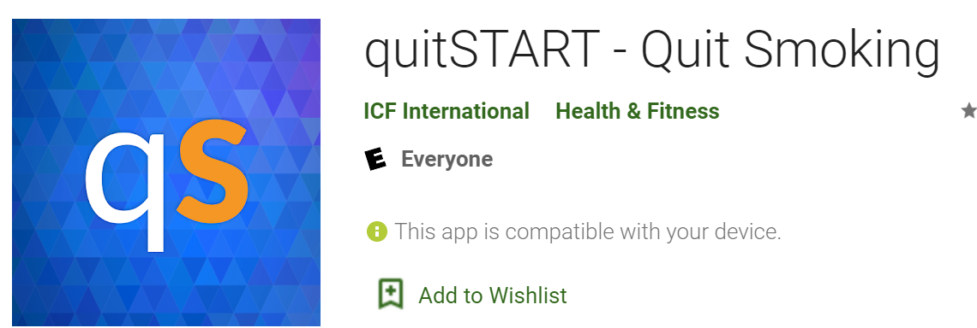

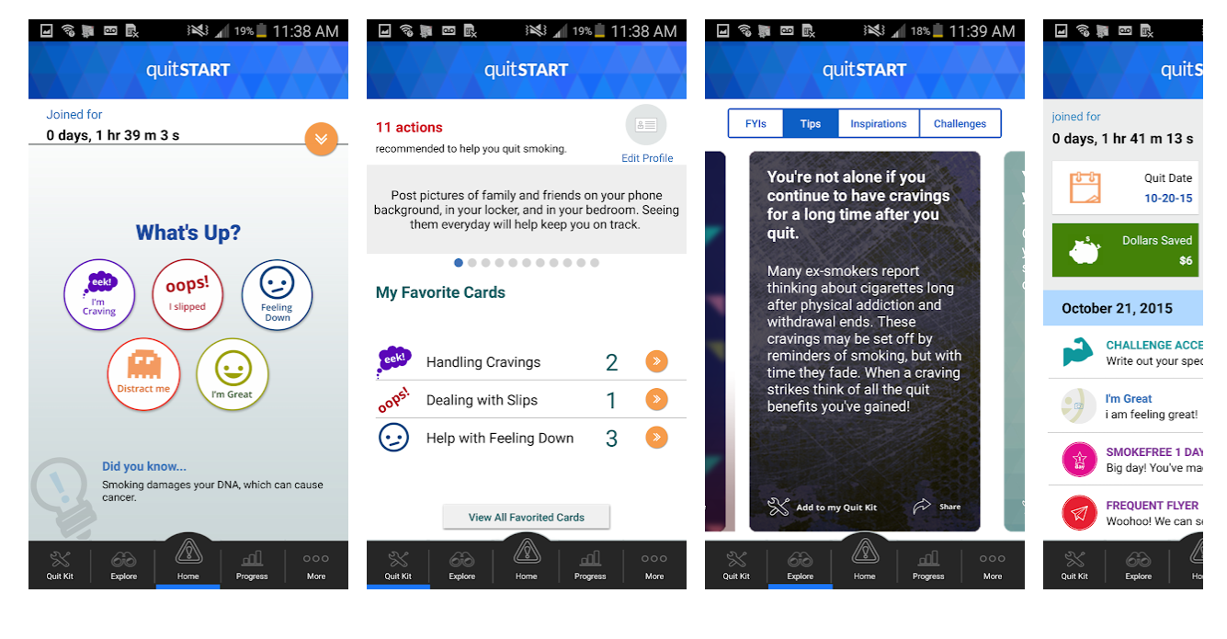
quitSTART is a free app made for people who want to quit smoking. This app takes the information you provide about your smoking history and gives you tailored tips, inspiration, and challenges to help you become smokefree and live a healthier life.
quitSTART helps you:
• Get ready to quit with tips and information to prepare you for becoming smokefree
• Monitor your progress and earn badges for smokefree milestones and other achievements
• Get back on track if you slip and smoke
• Manage cravings and bad moods in healthy ways
• Distract yourself from cravings with games and challenges
• Store helpful tips, inspirations, and challenges in your Quit Kit
• Share your progress and favorite tips through social media
quitSTART is a product of Smokefree.gov, a smoking cessation resource created by the Tobacco Control Research Branch at the National Cancer Institute in collaboration with the U.S. Food and Drug Administration and input from tobacco control professionals, smoking cessation experts, and ex-smokers.

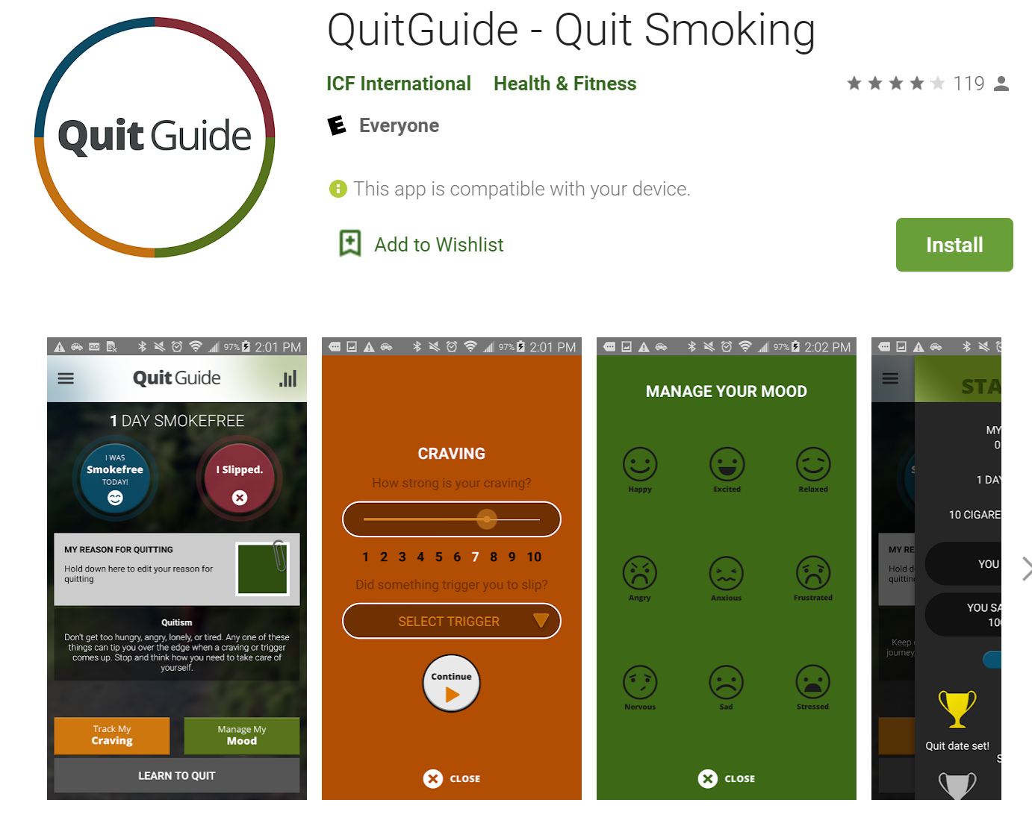
QuitGuide is a free smartphone app that can help you quit smoking. You can track your cigarette cravings and moods, monitor your progress toward achieving smokefree milestones, discover your reasons for quitting smoking, identify smoking triggers and develop strategies to deal with them, get expert guidance on how to quit smoking and address nicotine withdrawal, and access a variety of other strategies to help you successfully become and stay smokefree.
QuitGuide provides tips to use during cravings. Use these tips to help you manage your mood and stay smokefree. QuitGuide also gives you the ability to track cravings by time of day and location, so you can receive support when and where you need it. To get more tips and support, you can also visit the smokefree.gov website.
QuitGuide is a product of Smokefree.gov (SfG)—a smoking cessation resource created by the Tobacco Control Research Branch at the National Cancer Institute in collaboration with tobacco control professionals and smoking cessation experts and with input from ex-smokers.

The EX Plan: a customized quit plan that learns and grows with you. Includes an active social community, text and email messaging support, expert guidance and interactive quitting tool. www.becomeanex.org

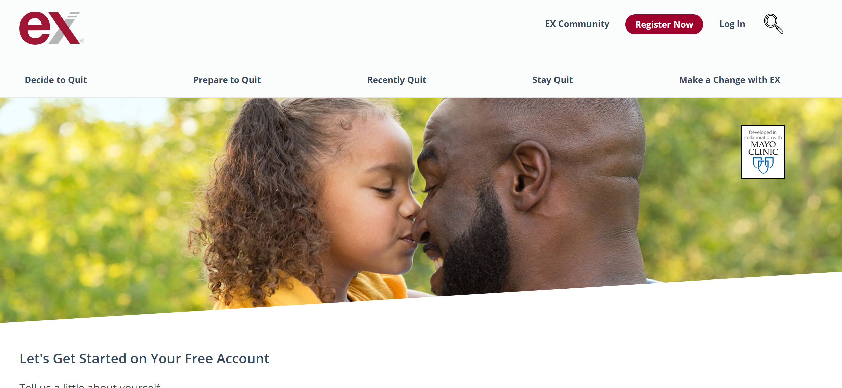
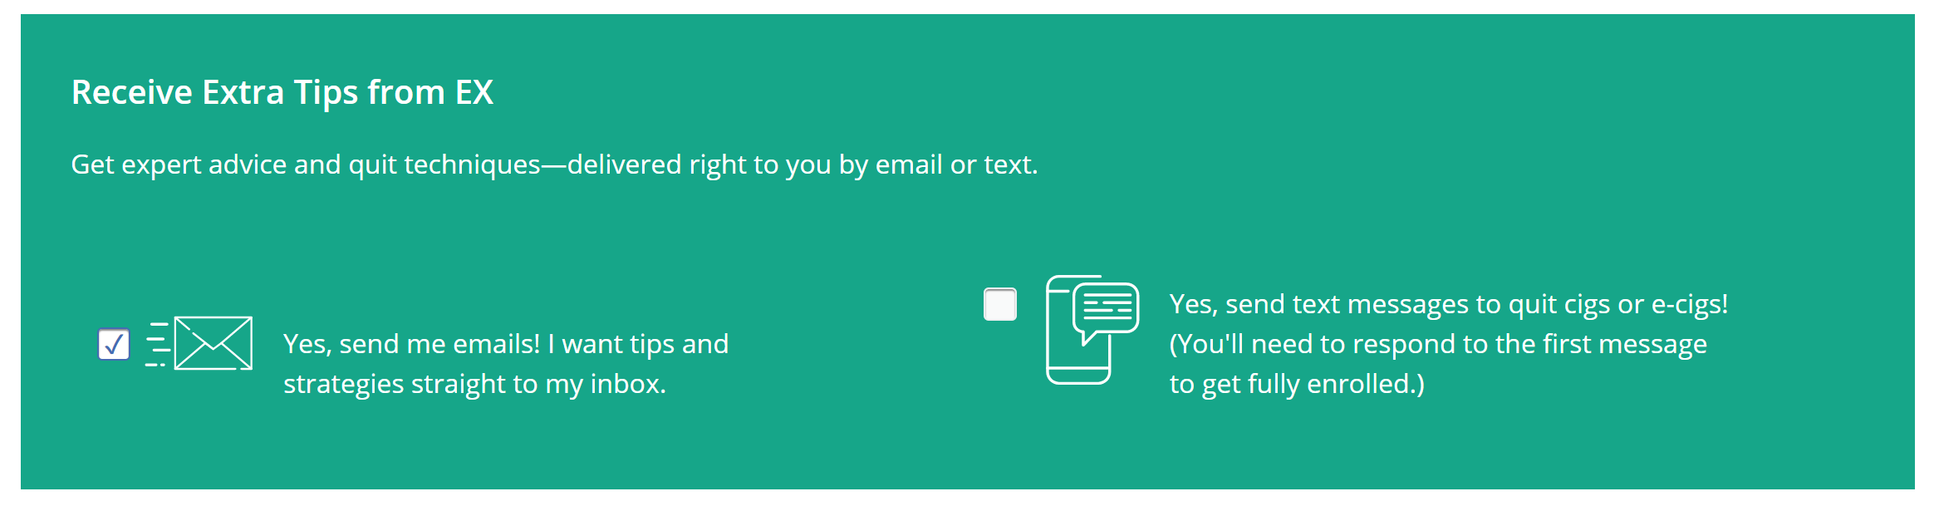
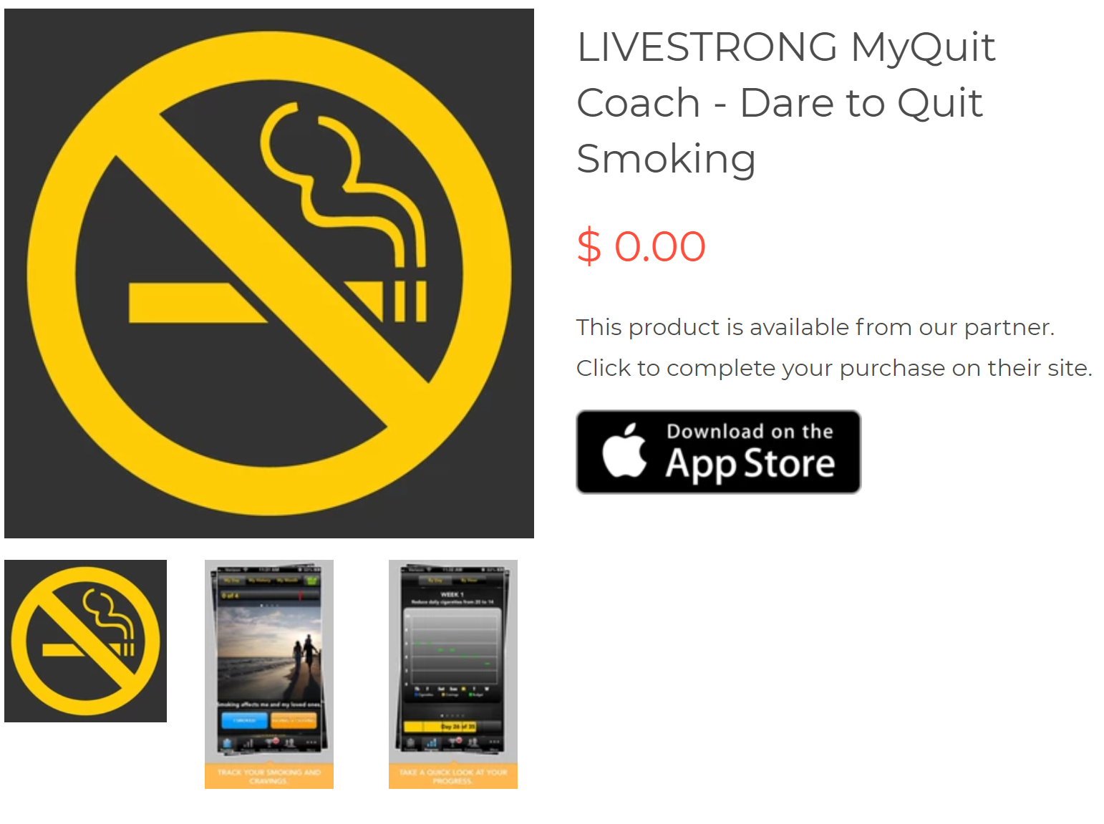
Only available on Apple products
The LIVESTRONG.COM MyQuit Coach application creates a personalized plan to help you quit smoking. Through a physician approved, interactive and easy to use app, you’ll evaluate your current status, set attainable goals and adjust preferences according to your needs. You'll finally be able to stop smoking.
You will have the option to choose to quit smoking right away or gradually decrease your daily nicotine intake—tracking the times you smoke and have nicotine cravings along the way. Personalized inspirational photos, motivational tips and progress charts will provide quit smoking help and keep you on track while achievement badges will reward you for progress. And you’re not alone with a built in social support circle and the option to update your Facebook and Twitter as friends cheer you on. When you are ready to stop smoking, let MyQuit Coach be your guide.
Features:
* Personalized quitting plan
* Upload your own personalized motivations
* Track your daily consumption and allowance
* Optional budget alerts and reminders
* Earn badges and awards
* View charts of your usage history by date and time
* Your plan will automatically adjust if necessary
* Quitting tips, facts, and motivation from LIVESTRONG.COM
* Get support through Facebook, Twitter, and LIVESTRONG.COM
The LIVESTRONG.COM MyQuit Coach application has been reviewed by smoking cessation specialist Dr. Jonathan Foulds, nicotine addiction specialist Dr. Dorothy Hatsukami, psychologist Dr. Belisa Vranich and cardiologist and internist Dr. Leslie Saxon.
LIVESTRONG.COM inspires and empowers people to achieve their daily goals around living healthy. The website connects visitors with useful tools, trustworthy information and a passionate, engaged community of likeminded people, who are willing to share their experiences.

